  - ABOUT THE PROJECT
The project named Online Hostel Management System is a software developed for
managing various activities in th hostel.For the past few years the number of educational
institutions is increasing rapidly. There by the number of hostels is also increasing for
the accommodation of the students studying in these institutions.And hence there is a lot
of strain on the person who are running the hostel and the software’s are not usually used
in this context.This particular project deals with the problem on managing a hostel and
avoids the problems which occur when carried manually.We can improve the efficiency
of the system,thus overcoming the drawbacks of the existing hostel management system.
In this proposed project online hostel management system ,students can book
hostel rooms which is the main functionality .Students can book according to the
different categories of room available such as AC/NONAC and can do online
payment.Also students can get refund when they want to cancel the booking which is one
of the application of the system
It is very smooth ,efficient and fast system. Generating report by accessing
information stored in database is another important feature of this system. This system
will able to generate as per user requirement in user friendly manner. User does not
require any technical details to generate reports. It is very helpfulf or the administrator.
The manual system had many difficulties and limitations. Through the process of
computerisation,the manual system overcomes the difficulties and limitations. We had
designed the system to overcome these limitation.

.

2.1 SYSTEM STUDY
2.1.1 Existing system
In existing system, to book hostel we use a manual system. In the present system all the activities are performed manually. All data entry is performed by writing data into the book, paper documents .The record are prepared manually , so there is a chance for occurring errors and the calculations are not so accurate. Various information such as students details, booking details, payment details are handled manually. When there is need for retrieving details searching is unavoidable, this is a difficult task searching the records manually.
The existing system uses manual method for whole process. This requires a lot of hard work and time consumption to complete the task. This may include human errors. In this existing system, it is difficult to retrieve some particular information. Also, all the records are stored manually and it is tedious task. As a result the security of these records is always a challenging task. Hence, the computerization of the system of record maintenance is the only solution to reduce the shortcomings of existing system.
Disadvantages of existing system
- Time consuming and improper planning and scheduling.
- High storage space.
- Less interactive.
- Requires more man power.
- High maintenance costs.

2.1.2 Proposed System
The proposed system is interactive, highly user friendly and designed exclusively for the Hostel. The Online Hostel Management System is a database system used to store the information regarding student details, booking details, payment details, room details etc.
All the operations and activities related to The Online Hostel Management System can be carried out efficiently. The system manages a well-organized database for storing the resources that they are providing by the Hostel. This help us to eliminate the entering of invalid data. Most problems of manual system can be solved by this system.
The computerization of the system allows the easy maintenance of the details. Large amount of data can be stored easily. In addition, updating and other changes can be done easily. The information can be retrieved with high speed and accuracy. The use of GUI oriented software makes the system user friendly.
Advantages of Proposed System
- High processing speed.
- Easy to retrieve old records by using search feature
- We can analyze student details, booking details, payment details, room details.
- The Online Hostel Management System shall provide the capability to back up the database.
- Minimal errors.
- Greater portability.
- User friendly.
- Reduced workload.

2.1.3 Feasibility Study
Feasibility study is made to see if the project on completion will serve the purpose of the organization for the amount of work, time and effort spent on it .
Study lets the developers foresee the future of the project and its usefulness. Finding out whether a new system is required or not.
The study is carried out to the best system that meet performance requirement.
This entails identification, description and evaluation of candidate system and selection of the best system for the job. It simply identifies whether the proposed system is feasible to the organization or not.
There are three aspects in the feasibility study portion of the preliminary investigation
- Technical feasibility
- Economic feasibility
- Operational feasibility
2.1.3.1 Technical Feasibility
The Online Hostel Management System must be evaluated from technical viewpoint first. The assessment of this feasibility must be based on an outline design of the system requirement in the terms of input, output, programs and procedure having identified an outline system, the investigation must go on to suggest the type of equipment , required method of developing the system, method of running the system once it has been designed. The project should be developed such that the necessary functions and performance are achieved within the constraints. The project is developed with latest technology. There are only minimal constraints involved in this project.

2.1.3.2 Economic Feasibility
Here an evaluation of development cost is weighted against the ultimate income or benefit derived from the developed system. The cost for the development of the project has been evaluated and we want to check that the cost does not exceed beneficial cost of the system. The economic and financial analysis is used for evaluating the effectiveness of the candidate system. This project also undergone economic feasibility study and found that it is feasible. So the cost for development does not exceed its beneficial cost. This brought to as the conclusion that the system is economically feasible in the context.

2.1.3.3 Operational Feasibility
In operational feasibility the entire application is checked whether the system will be used if it is developed and implemented. Also it is checked whether there will be resistance from user that may undermine the possible application benefits. There is no barrier for implementing the system. The system also helps to access the information immediately as need arises. Thus the system is found to be operational feasible.

2.2 USER CHARACTERISTICS
This software has two users
- Administrator
- Student
Administrator:
Administrator is the primary user who has the most whole control over the software. Administrator administrates over the entire activities of the system and has full control over what all happens in the Hostel. He/she is the only user who can see, change or delete details of a student.
Student:
Student is the secondary user . Students have to register themselves . They have
thefunctions like viewing the rooms and booking the room. A Student can only book
one room, more than one room for a student is not permitted

2.3 SYSTEM SPECIFICATION
2.3.1 Hardware Specification
The selection of hardware and software configuration is very important task related to system development.
Processor | Intel Pentium IV (3.0 GHz) or above
RAM | 8 GB
Hard Disk | 931 GB
Key Board | Standard PS/2 keyborad
Monitor | Generic PnP Monitor
Mouse | Compatible Mouse

2.3.2 Software Specification
Operating System | Windows
Front End | PHP
Back End | Mysql

2.3.3 ABOUT THE SOFTWARE TOOLS
FRONT END SPECIFICATION: PHP
PHP is a powerful server-side scripting language for creating dynamic and interactive websites. PHP is the widely-used, free, and efficient alternative to competitors such as Microsoft's ASP. PHP is perfectly suited for Web development and can be embedded directly into the HTML code. The PHP syntax is very similar to Perl and C. PHP is often used together with Apache (web server) on various operating systems. It also supports ISAPI and can be used with Microsoft's IIS on Windows.PHP is an embedded scripting language that is excellent for creating dynamic Web sites based on database content or different characteristics of browsers. It is available when you have a Departmental (Web Central) Publishing account, a Faculty Publishing account, a Student Organization Publishing account, or if you use Custom Web Publishing.

Features
- Allows you to build templates to ease site maintenance
- Serve different content to users based on their browser, IP address, date and time, or numerous other characteristics
- Enables connections with databases such as MySQL
- Build discussion forums or Web-based email programs
Characteristics of PHP
- Objected Oriented
- Complied and Interpreted
- Portable
- Distributed
- Secure

MYSQL
Many programming language with language specific APIs include libraries for accessing MySQL databases.These include MySQL Connector/Net for integration with Microsoft's Visual Studio (languages such as C# and VB are most commonly used) and the JDBC driver for Java. In addition, an ODBC interface called MySQL Connector/ODBC allows additional programming languages that support the ODBC interface to communicate with a MySQL database, such as ASP or ColdFusion. The HTSQL – URL-based query method also ships with a MySQL adapter, allowing direct interaction between a MySQL database and any web client via structured URLs. Other drivers exists for languages like Python or Node.js

SYSTEM MODELING
The most creative and challenging phase of the system development is system design. It provides the understanding and procedural details necessary for implementing the system recommended in the feasibility study. Design goes through the logical and physical stages of development.
In designing a new system, the system analyst must have a clear understanding of the objectives, which the design is aiming to fulfill. The first step is to determine how the output is to be produced and in what format. Second input data and master files have to be designed to meet the requirements of the proposed output. The operational phases are handled through program construction and testing. The point is to choose such an environment in which we will be able to operate with in a convenient and easy way. The most creative and challenging phase of the system development is system design. It provides the understanding and the procedural details necessary for implementing the system recommended in the feasibility study. The analyst should understand the requirements of the user and develop the system accordingly. Design goes through the logical and physical stages of development. In designing a new system, the system analyst must have a clear understanding of the objectives, which the design is aiming to fulfill. The application program as an interface between the users and the database should be an accurate reflection of the database on the screen; hence a well analyzed and defined structure is needed. The user interface should be easy to understand and operate on for the users. The first step is to determine how the output is to be produced and in what format it has to be produced. Second, input data along with the master files have to be designed to meet the requirements of the proposed output.
The analyst must ensure that the interaction between the user and the interface is simple to understand. To ensure that everything works properly and as it has been expected, test performances have to be done upon the system functionality. Testing plays an important role in identifying any minor errors after system design and it will be corrected.

3.1 MODULES AND DESCRIPTION
The most creative and challenging phase of the system development is system design. It
provides the understanding and procedural details necessary for implementing the
system recommended in the feasibility study. Design goes through the logical and
physical stages of development.The main objective of the application is to computerize
the existing system of manually maintain the records of thestudent,booking. We have
mainly 5 modules. They are:
1.Student Registration
2.Room Management
3.Booking Management
4.Payment Management
5.Refund Management

- STUDENT REGISTRATION
This section is the description of the student details. The admin update and also
remove the students. The student can register and book there rooms. A student
can only book one room. Student can view the rooms and book the rooms.

- ROOM MANAGEMENT
Here, the admin allocate the rooms for the students.If any of them needed any kind of special consideration will be provided by the admin. The total number of rooms are specified and allocated to the students. Apart from this the admin can add, update rooms to the existing system. The necessary things for the rooms will be provided by the admin.In room management we have other two modules

2.1 ROOM CATEGORY MANAGEMENT
Room category involves the following category list of rooms.
- A/C [SINGLE BED, DOUBLE BED]
- NON A/C [SINGLE BED, DOUBLE BED]
- A/C ATTACHED [SINGLE BED, DOUBLE BED]
- NON A/C ATTACHED [SINGLE BED, DOUBLE BED]
  - ROOM DETAILS MANAGEMENT
Room details includes the details of the room such as room number, room capacity,
room status, room loor, room id, and room rent.

3. BOOKING MANAGEMENT
It is an important module in this system. Student can book the rooms after registering.
One room for one student. The rooms for students will be allocated by the admin . The
admin can edit and view the booking details any time if it is required. If the rooms are
already allocated ,the room status will be automatically ALREADY BOOKED.

4.PAYMENT MANAGEMENT
It is an important module in this system. Admin will collect the fee from thestudents.
Here, we consider room fee and make the total amount to be paid by a student. The
admin can update the fee details any time if it is required. The rent of the room varies
for different rooms.

5.REFUND MANAGEMENT
In this module the student can request for cancellation and refund.The admin can approve or reject the request

3.2 DATA FLOW DIAGRAM (DFD)
A data flow diagram is graphical tool used to describe and analyze movement of data through a system. These are central tool and the basis from which the other components are developed. The transformation of data from input to output, trough processed, may be described logically and independently of physical components associated with the system. These are known as the logical data flow movement of data between people, departments and workstations. A full description of a system actually consists of a set of data flow diagrams.
A DFD is also known as a “bubble chart” has the purpose of clarifying system requirements and identifying major transformations that will become programs in system design. So it is the starting point of the design to the lowest level of detail. A DFD consists of a series of bubbles joined by data flows in the system.
In the DFD, there are four symbols

Process that transforms data flow

Source or Destination of data

Data store

Data flow

Rules for drawing data flow diagrams
Rule 1: Establish the context of the data flow diagram by identifying all of the net input and output data
flows
Rule 2: Select a starting point for drawing the DFD.
Rule 3: Give meaningful labels to all data flow lines.
Rule 4: Label all processes with action verbs that relate input and output data flows.
Rule 5: Omit insignificant functions routinely handled in the programming process.
Rule 6: Do not include control or flow of control information.
Rule 7: Do not try to put too much information in one DFD.
Rule 8: Be prepared to start over

Level 0 DFD Showing Online Hostel Management System

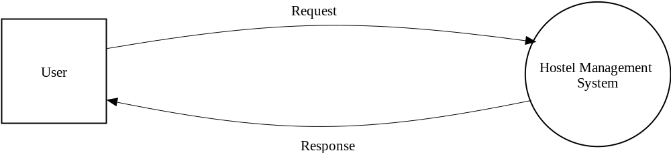

Level 1 DFD Showing Online Hostel Management System

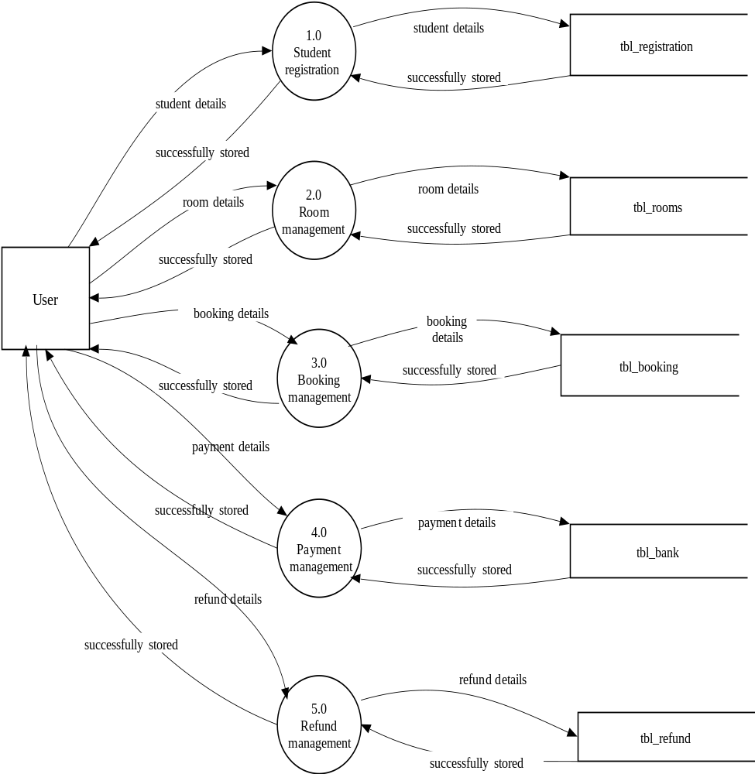

Level 2 DFD Showing Student Registration

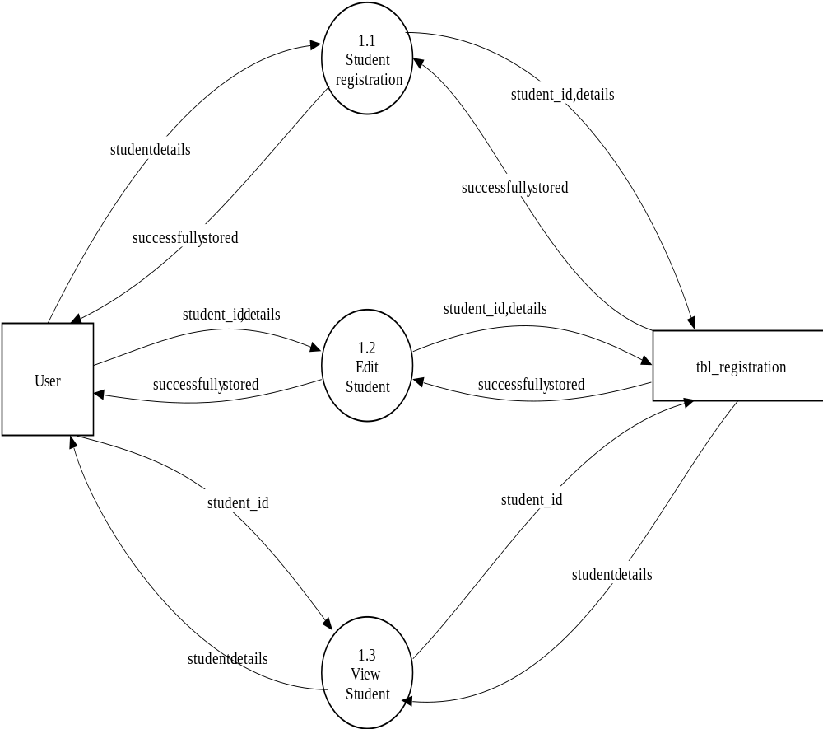

Level 2 DFD Showing Room Management

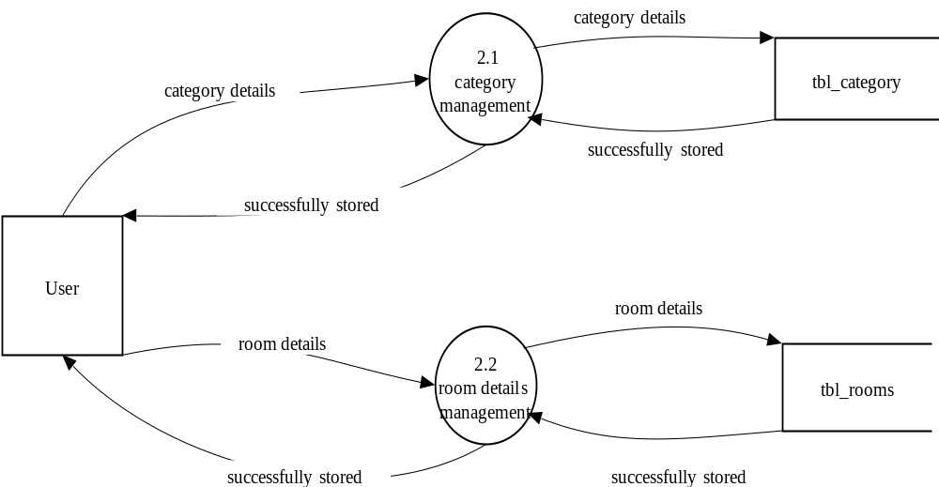

Level 2 DFD Showing Booking Management

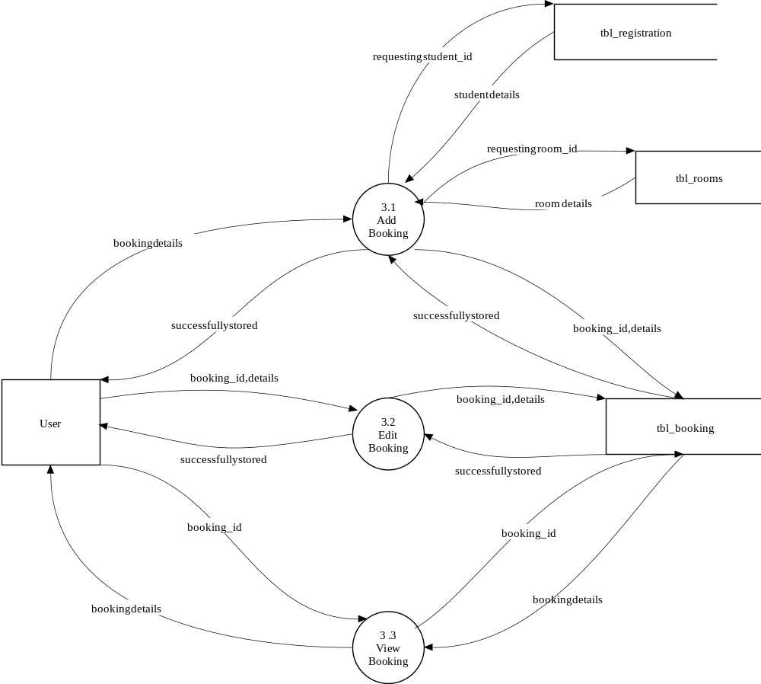

Level 2 DFD Showing Payment Management

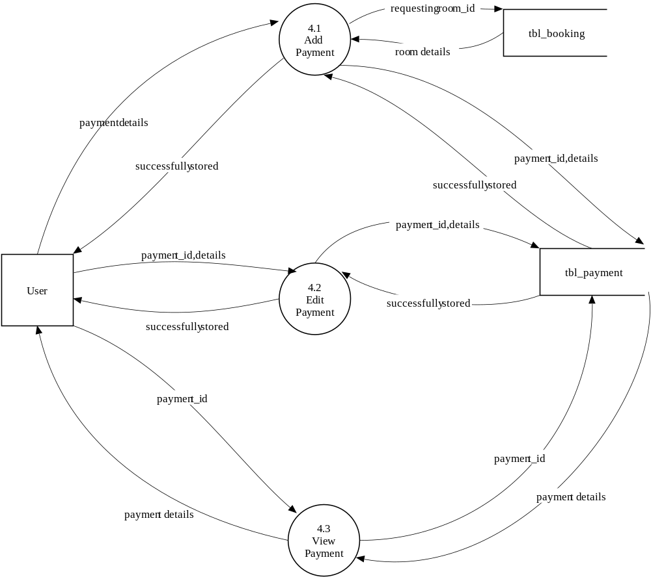

Level 2 DFD Showing Refund Management

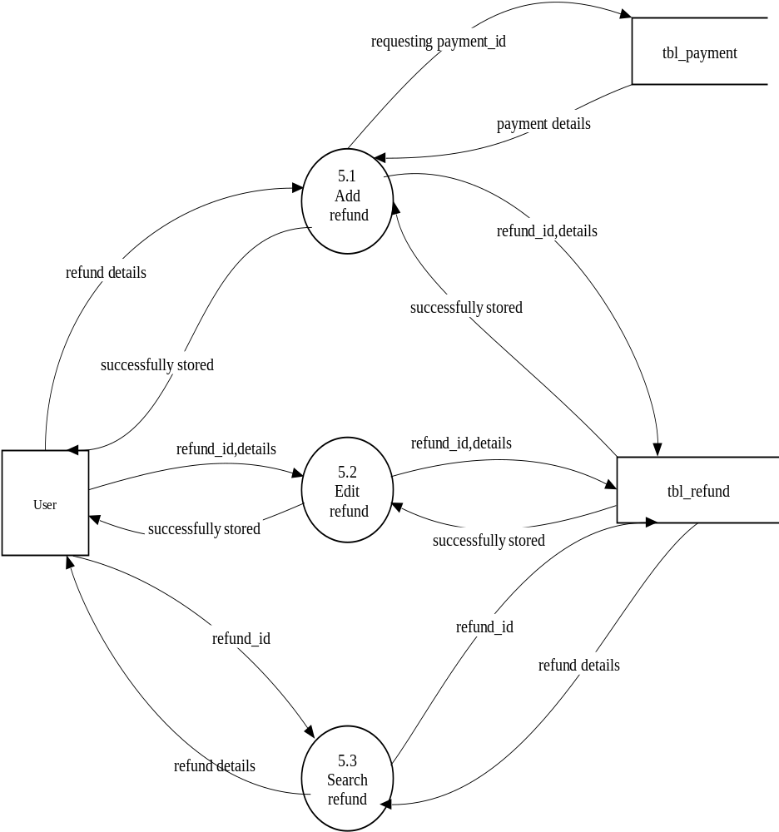

Level 3 DFD Showing Category Management

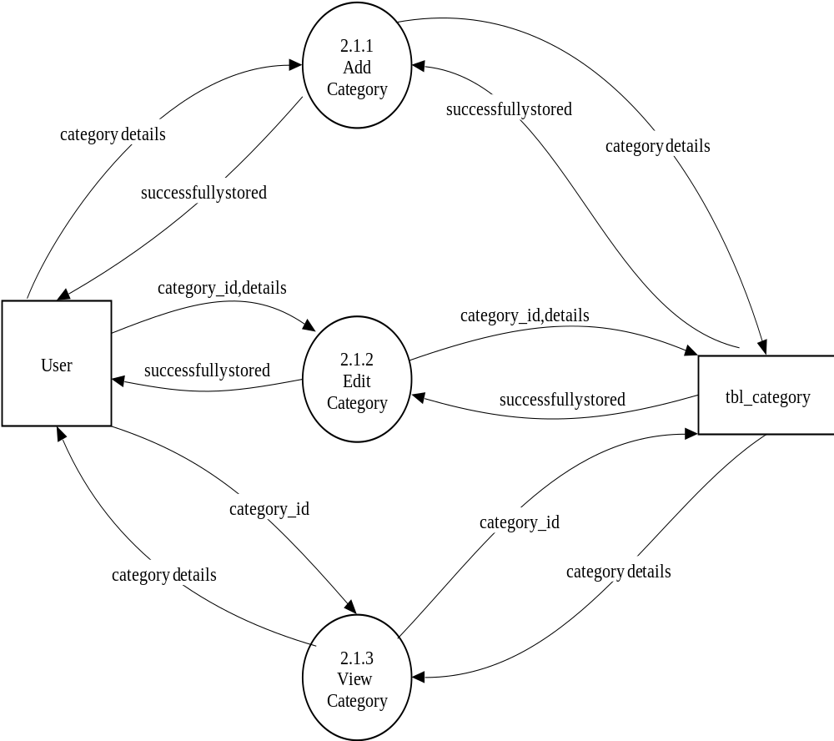

Level 3 DFD Showing Room Details Management

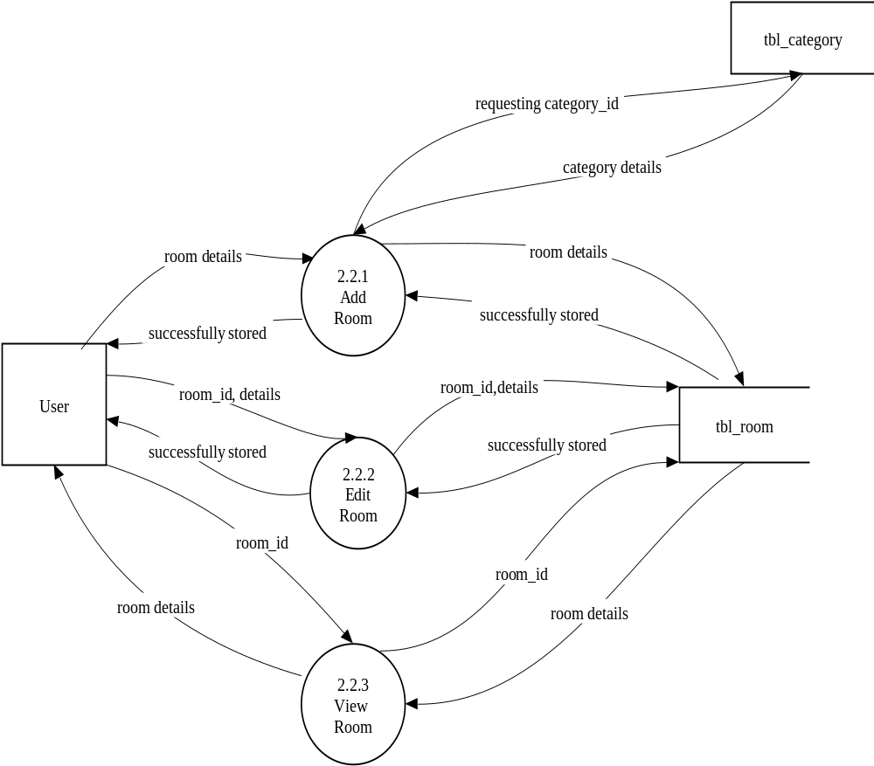

3.3 ENTITY RELATIONSHIP DIAGRAM
The ER model is a conceptual data model that views the real world as a construct of entities and associations or relationships between entities. A basic component of the model is the Entity-Relationship diagram, which is used to visually represent data objects. The ER modeling technique is frequently used for the conceptual design of database applications and many database applications and many database design tools employ its concepts.

Entity Type

Weak Entity Type

Relationship Type

Attribute

Key attribute

Multivalued Attribute

ER DIAGRAM
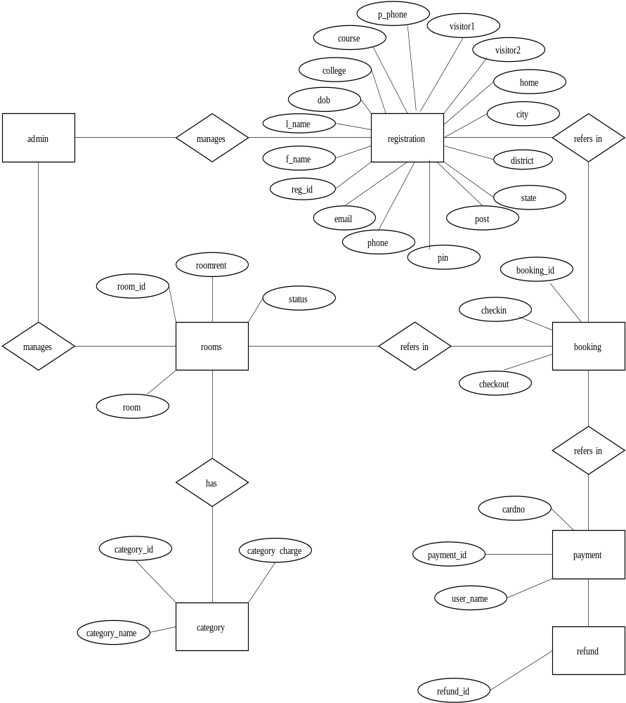

4.1 INPUT DESIGN
Input design is the process of converting a user-oriented description of the inputs to a computer-based business system into a programmer-oriented specification. The quality of system input determines the quality of system output. Input specification describes the manner in which data enter the system for processing .Input design features can ensure the reliability of the system and produce result from accurate data or they can result in the production of errors. The input design also determines whether the user can interact efficiently with the system.
Input design requires consideration of the needs of the data entry operator. Three data entry considerations are:
- The field length must be documented
- The sequence of fields must match the sequence of the fields on the source document.
- The data format must be identified to the data entry operator.
In our system almost all inputs are being taken from the databases. To provide adequate inputs we have to select necessary values from the databases and arrange it to the appropriate controls.
Inaccurate input data are the most common cause of errors in data processing. Errors entered by data entry can be controlled by input design. Input design is the process of converting user-oriented inputs to a computer based format. There are three major approaches for entering data into the computer. They are menus, formatted forms and prompts. A menu is a selection list that simplifies computer data access or entry. Instead of remembering what to enter, the user choices from a list of option. A formatted form is a preprinted form or a template that request the user to enter data in appropriate location. It is a fill-in-the-blank type form. The form is flashed on the screen as a unit. In prompt the system displays one enquiry at a time, asking the user for a response.

Home Page Form
Description: This form shows the Home page for all the users 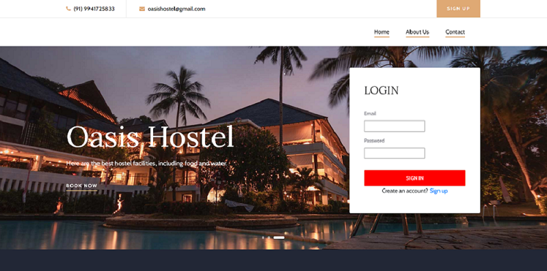

Registration Form
Description: This form shows the registration page for all the users.
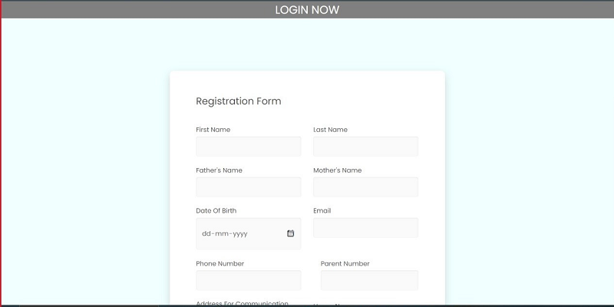
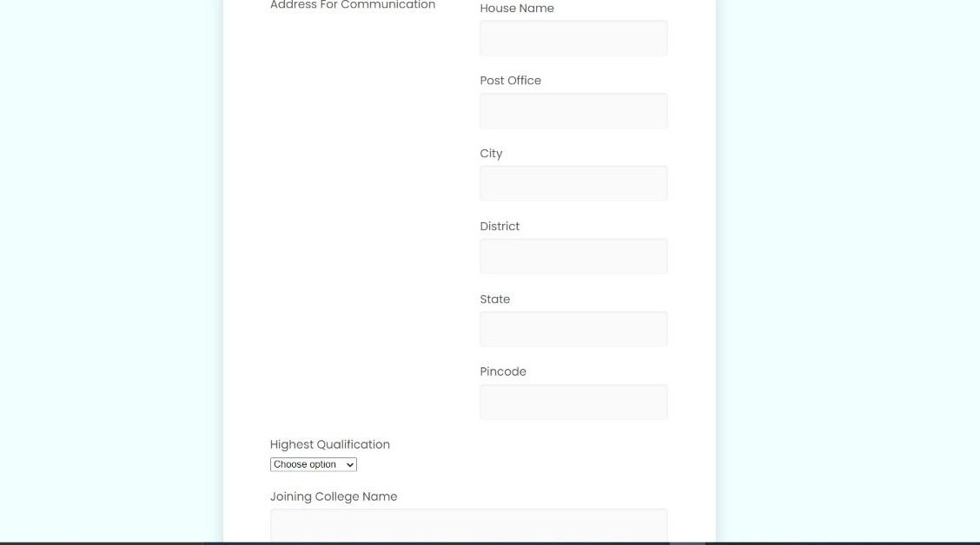
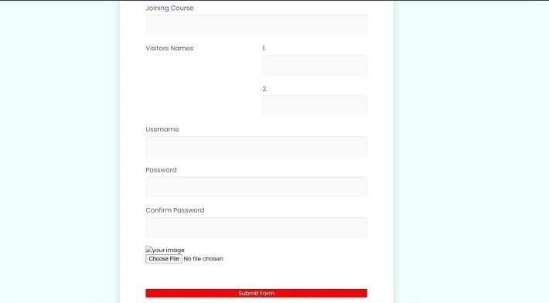

Booking Form
Description: This form shows the Booking page .
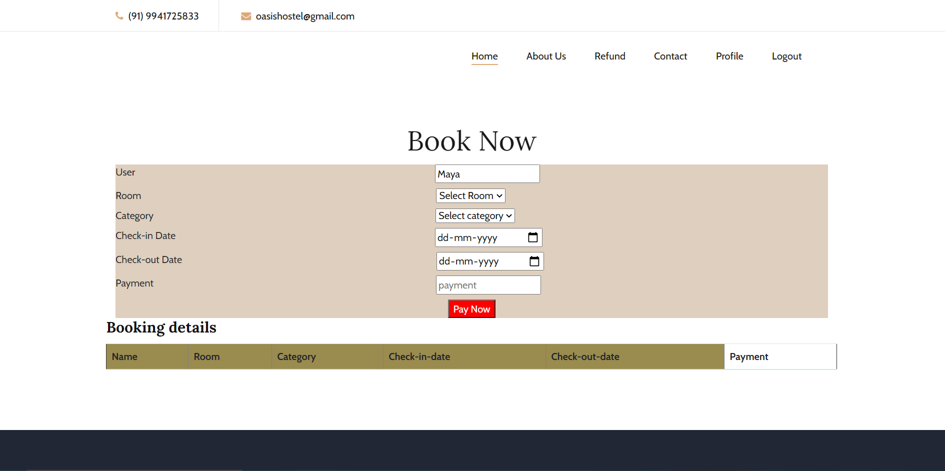

Payment Form
Description: This form shows the payment page
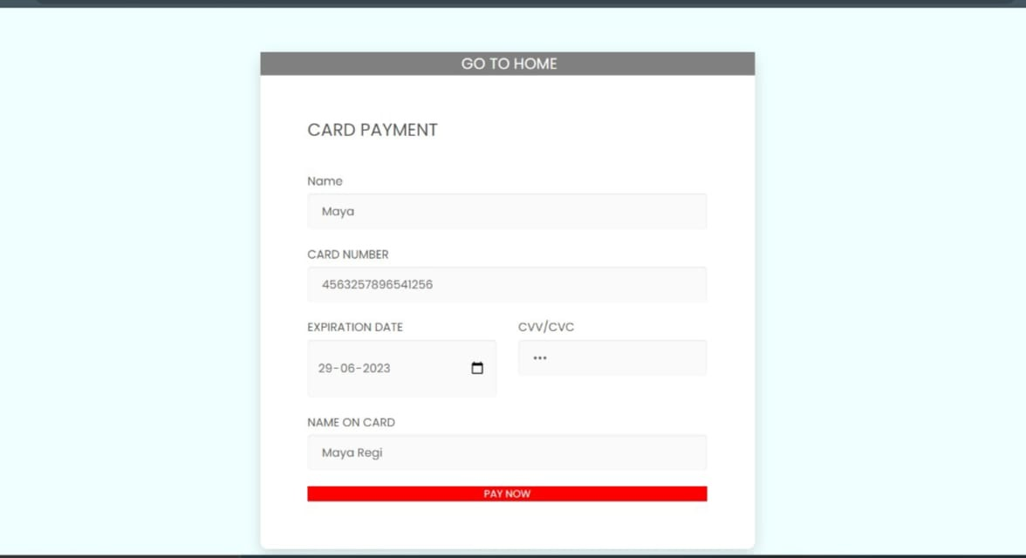

Refund Form
Description: This form shows the refund page for new users.
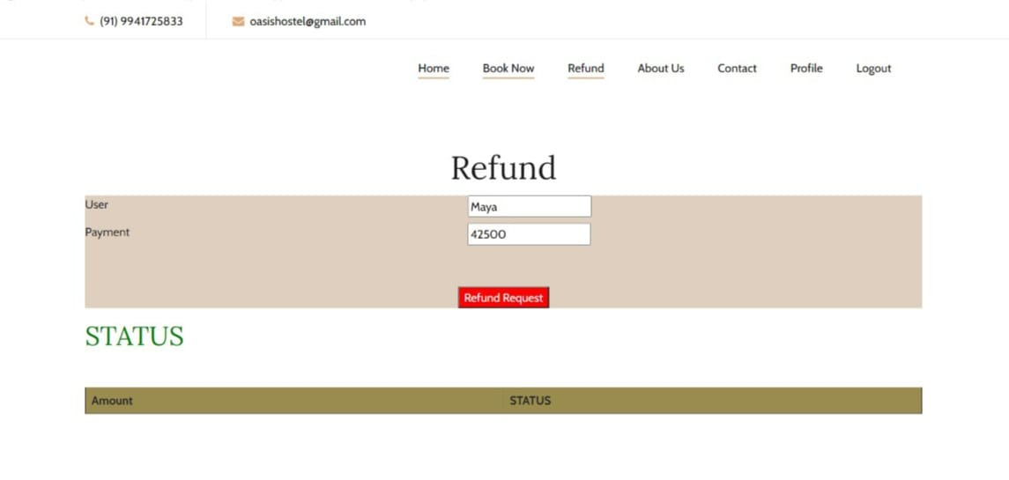
Admin Form
Description: This form shows admin page
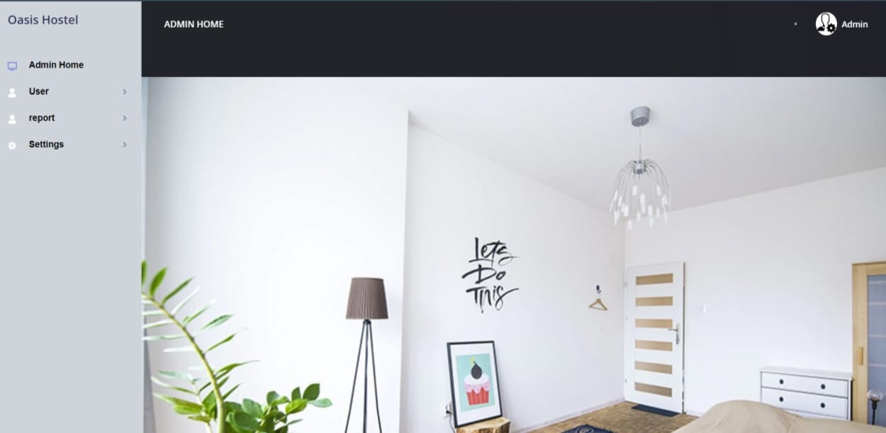

Room details Form
Description: This form shows the room details page
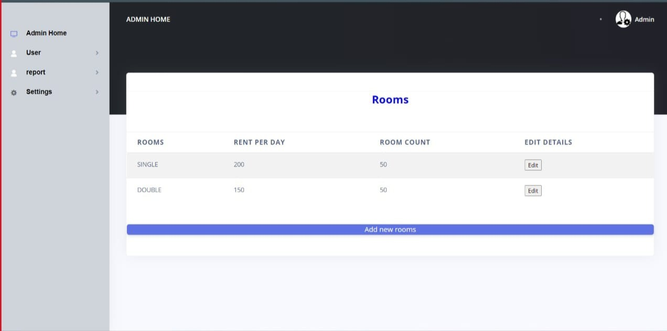
Category details Form
Description: This form shows the category details page
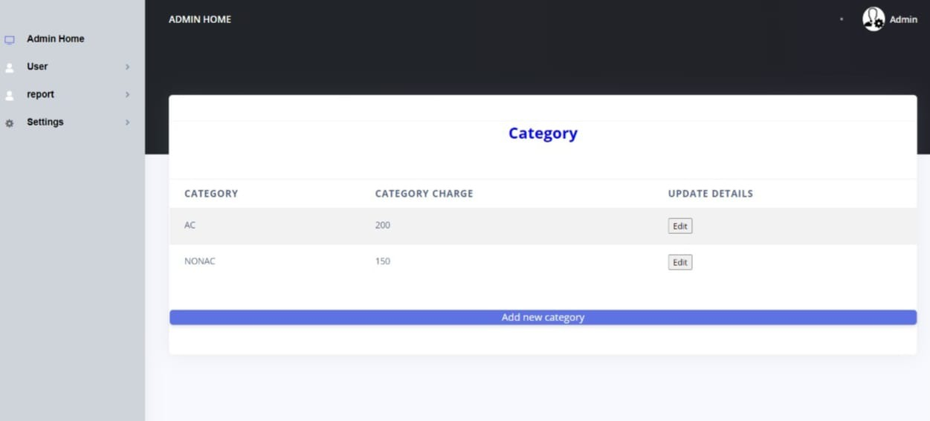

4.2 OUTPUT DESIGN
One of the important features of an information system for users is the output it produces. Output is the information delivered to users through the information system. Without quality output, the entire system appears to be unnecessary that users will avoid using it. Uses generally merit the system solely by its output. In order to create the most useful output possible. One works closely with the user through an interactive process, until the result is considered to be satisfactory.
Output design has been an ongoing activity almost from the beginning of the project. In the study phase, outputs were identified and described general in the project directive. A tentative output medium was then selected and sketches made for each output. In the feasibility analysis, a “best” new system was selected; its description identified the input and output media. In the design phase the system has included an evaluation and selection of specific equipment for the system.
Output design generally deals with the results generated by the system i.e., reports. These reports can be generated from stored or calculated values. Reports are displayed either as screen window preview or printed form. Most end users will not actually operate the information system or enter data through workstation, but they will use the output from the system.
Outputs from computer systems are required primarily to communicate the results of processing to the user. They are also used to provide a permanent copy of these results for later consultation.

Student Details Form
Description: This form displays Student details.
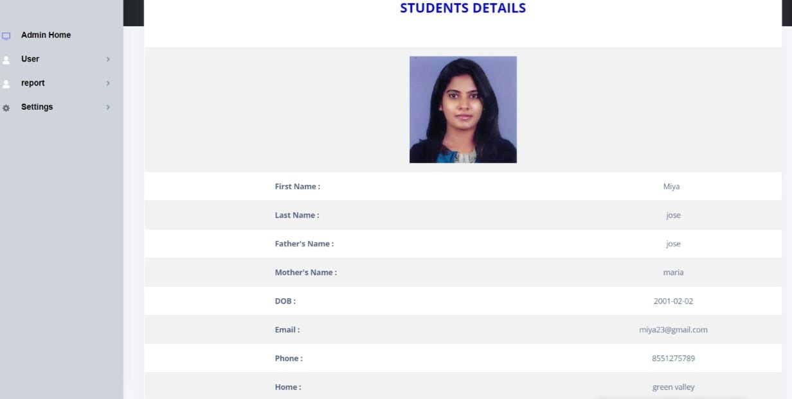
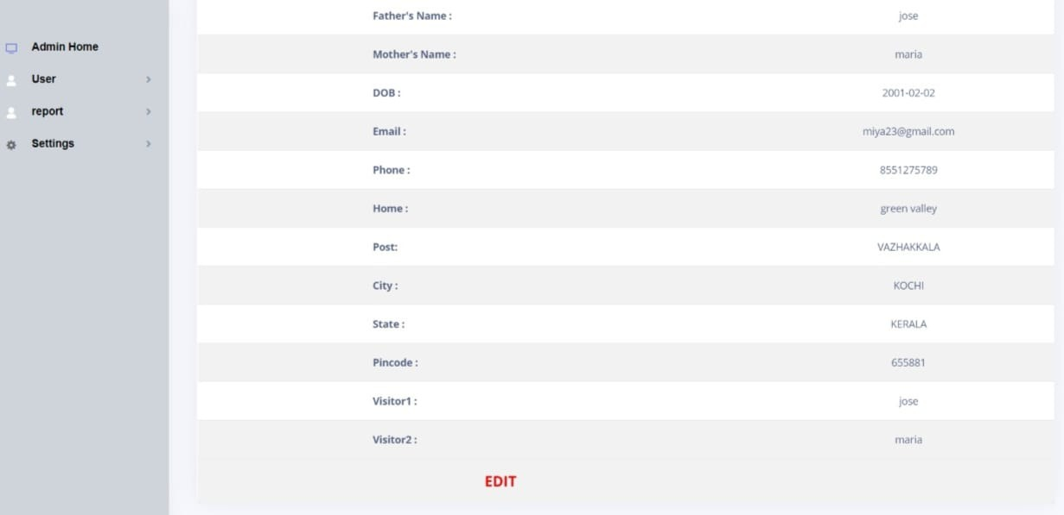

Student Report.
Description: This report shows the student report
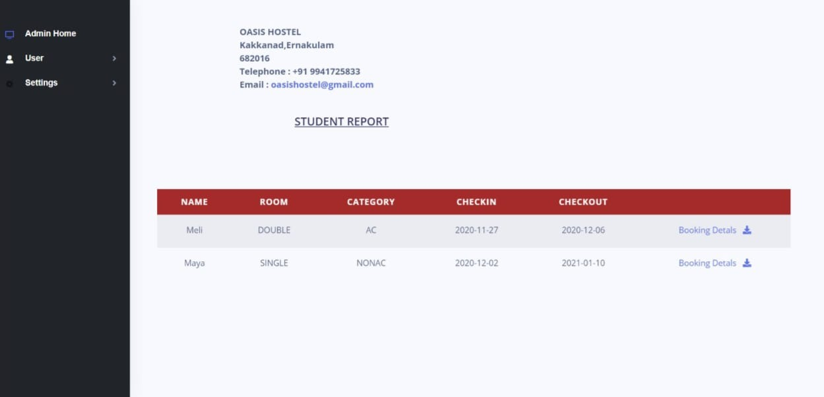

Booking Report.
Description: This report shows the booking report
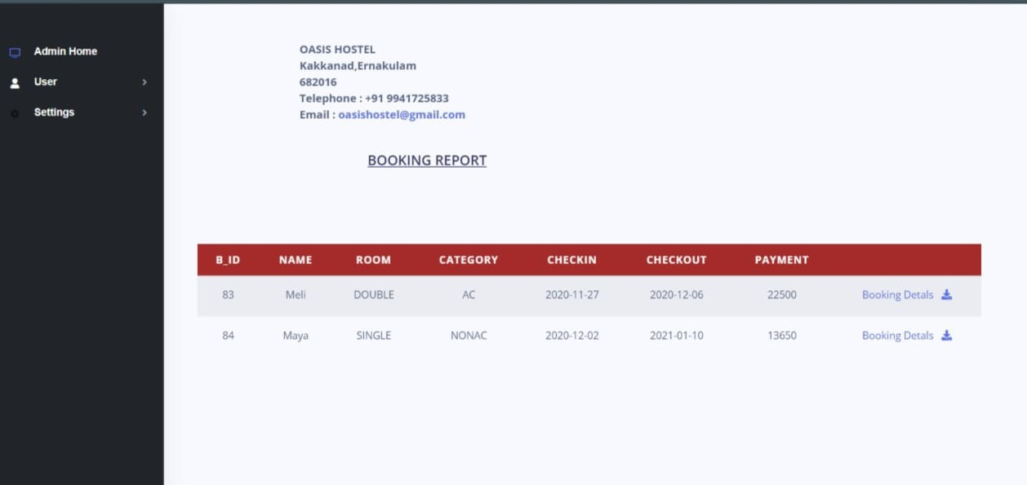

Payment Report.
Description: This report shows the payment report
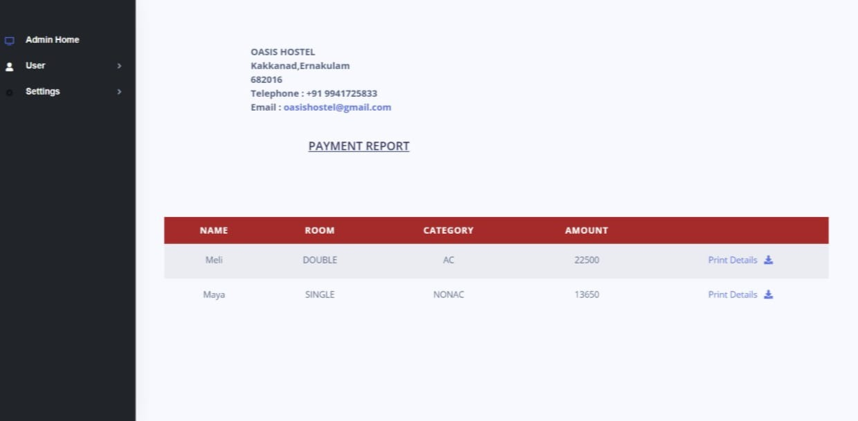
Refund Report.
Description: This report shows the refund report
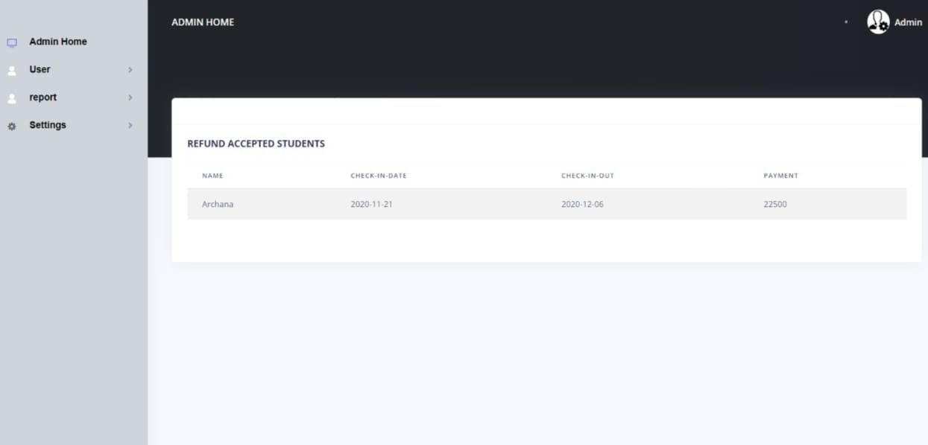

4.3. DATABASE DESIGN
4.3.1 NORMALIZATION
Designing a database is a complex task and the normalization theory is a useful aid in this design process. The process of normalization is concerned with transformation of conceptual schema into computer representation form.
A bad database design may lead to certain undesirable situation such us,
- Repetition of information
- Inability to represent certain information
- Loss of information
To minimize these anomalies, normalization mat be used. If the database is in a normalization form, the data can be restructured and can maintain it easily. This is important that the database using that we are using may free from data redundancy and inconsistency. For this need we maintain the tables in a normalized manner.
First Normal Form
A relation is in first normal form (INF), if and only if all its attributes are based on single domain. The objective of normalizing a table is in to remove its repeating groups and ensure that all entries of the resulting table have at most single value.
Second Normal Form
A table is said to be in Second Normal Form (2NF), when it is in 1NF and every attribute in the record is functionally dependent upon the whole key, and not just a part of the key.
Third Normal Form
A table is in third Normal Form (3NF), when it is in 2NF and every non-key attribute is functionally dependent on just the primary key.

TABLE DESIGN

Table Name: tbl_login
Table Description: table showing login Details

FIELD | DATATYPE | CONSTRAINT | DESCRITION
username | Varchar(30) | Not null | Username
password | Varchar(20) | Not null | Password of user
Type | Varchar(30) | Not null | User type

Table Name: tbl_registration
Table Description: table showing student details
FIELD | DATATYPE | CONSTRAINT | DESCRITION
Reg_id | Int(10) | Primary key | Student ID
F_name | Varchar(30) | Not null | First name
L_name | Varchar(30) | Not null | Last name
Fa_name | Varchar(30) | Not null | Fathers name
Mo_name | Varchar(30) | Not null | Mothers name
Dob | Date | Not null | date of birth
email | Varchar(50) | Not null | email
phone | Varchar(10) | Not null | Phonenumber of student
P_phone | Varchar(10) | Not null | Phonenumber of parent
home | Varchar(30) | Not null | home
city | Varchar(20) | Not null | city
district | Varchar(20) | Not null | District
state | Varchar(20) | Not null | State
pin | Varchar(20) | Not null | Pin code
qualification | Numeric(30) | Not null | Highest qualification
college | Varchar(30) | Not null | college name
course | Varchar(20) | Not null | Joining course name
Visitor1 | Varchar(20) | Not null | Visitor1
Visitor2 | Varchar(20) | Not null | Visitor2
username | Varchar(30) | Not null | username
password | Varchar(15) | Not null | password
confirmpassword | Varchar(15) | Not null | Confirm password
photo | Varchar(200) | Not null | Photo

Table Name: tbl_category
Table Description: table showing category details
FIELD | DATATYPE | CONSTRAINT | DESCRITION
Category_id | Varchar(20) | Primary key | Category ID
Category_name | Varchar(20) | Not null | Category name
C_charge | Varchar(20) | Not null | Category charge
status | Varchar(20) | Not null | status

Table Name: tbl_room
Table Description: table showing room details
FIELD | DATATYPE | CONSTRAINT | DESCRITION
Room_id | Varchar(20) | Primary key | Room ID
Category_id | Varchar(20) | Foreign key | Category ID
R_number | Varchar(20) | Not null | Room number
count | Int(100) | Not null | Count of rooms
rent | Int(11) | Not null | rent
Status | Varchar(20) | Not null | Status

Table Name: tbl_booking
Table Description: table showing booking details
FIELD | DATATYPE | CONSTRAINT | DESCRITION
Booking_id | Varchar(20) | Primary key | Booking ID
Reg_id | Varchar(20) | Foreign key | Student ID
Room_id | Varchar(20) | Foreign key | Room ID
Check_in | Date | Not null | Check in date
Check_out | Date | Not null | Check out date
Payment | Varchar(50) | Not null | payment
status | Varchar(20) | Not null | status

Table Name: tbl_cardpayment
Table Description: table showing payment details
FIELD | DATATYPE | CONSTRAINT | DESCRITION
C_id | Varchar(20) | Primary key | Card Payment ID
Reg_id | Varchar(20) | Foreign key | Student ID
cardholder | Varchar(20) | Not_null | Card holder name
Card_no | Varchar(20) | Not_null | Card number
cvv | Varchar(20) | Not_null | cvv
expiry | date | Not_null | Expiry date
status | Varchar(10) | Not_null | status

Table Name: tbl_payment
Table Description: table showing payment details
FIELD | DATATYPE | CONSTRAINT | DESCRITION
Payment_id | Varchar(20) | Primary key | Payment ID
Reg_id | Varchar(20) | Foreign key | Student ID
booking_id | Varchar(20) | Foreign key | Booking ID
C_id | Varchar(20) | Foreign key | Card payment ID
Payment_method | Varchar(20) | Not_null | Payment method
status | Varchar(10) | Not_null | status

Table Name: tbl_refund
Table Description: table showing refund details
FIELD | DATATYPE | CONSTRAINT | DESCRITION
Refund_id | Varchar(20) | Primary key | Refund ID
Payment_id | Varchar(20) | Foreign key | Payment ID
status | Varchar(20) | Not_null | status

5.1INTRODUCTION
Software testing can be looked upon among the many process in organization that provides the last opportunity to correct any plane in the development system. System testing includes selecting tests and test data that have more problem of finding errors. System testing is vital for the success of any software system. The system makes a logical assumption that all part of the system work efficiently and goal is achieved. The system is tested for online response, ability to store and stress recovery from failure and usability. System testing requires a test plan that consists of several key activities and steps for programming and user acceptance testing. Another benefit of system testing is its utility as a user oriented system before implementation.
LEVELS OF TESTING
Some of the methods of the system testing are given below.
Unit testing
In this test each module is tested individually before integration it to the final system. Unit test focuses verification in the smallest unit of software design in each module. This is also known as module testing. In this test each module is tested whether it is producing the desired output and if any error occurs it can be corrected easily.
Integration testing
It is the systematic technique for constructing the program structure while at the same time conducting test to uncover errors associated with interfacing. Thus the relationship between difference modules is checked in this testing for overall performance of testing. Thus in integration testing step, all errors uncovered are corrected for next testing steps. The objective of the test is to take althea modules such as administrator, user and modules are integrated in this testing step and then the entire program is tested.

Validation testing
It in where requirements established as a part of software requirements analysis is validated against the software that has been constructed. This test provides the final assurance that the software meets all functional, behavioral and performance requirements. The errors, which are uncovered during integration testing, are connected during this phase.
Output Testing
No system could be useful if it does not produce the required output in the specific format. Output testing is performed to ensure the correctness of the output and its format. The output generated or displayed by the system is tested asking the user about the format required by them.
User Acceptance Testing
The system under consideration is tested for user acceptance by constantly keeping in touch with the prospective system user at the time of developing. The testing of the software began along with the coding. The unit testing was done for each module in the software. For various inputs such that each line of code is executed at least once.

5.2 TEST CASES
A test plan document the strategy that will be used to verify and ensure that a product or system meets its design specification and other requirements. A test plan is usually prepared by or with significant input from test Engineers. Depending on the product and the responsibility of the organization to which the test plan applies.
Unit Testing
Form | Procedure | Expected Result | Actual Result | Status
Entry Form | Choose whether to Login,About us or Developers
Login Form | Enter valid username and password | Should validate user and provide link to user accounts | Got entry to accounts | Pass
Student form | Enter all mandatory fields | Should validate all entered fields and flash a message indicating successful registration | Message indicating successful registration is shown | Pass
booking Form | Enter all mandatory fields | Should validate all entered fields and flash a message indicating successful registration | Message indicating successful registration is shown | Pass
payment Form | Enter all mandatory fields | Should validate all entered fields and flash a message indicating successful registration | Message indicating successful registration is shown | Pass
Refund Form | Enter all mandatory fields | Should validate all entered fields and flash a message indicating successful registration | Message indicating successful registration is shown | Pass

Integration Testing
Form | Expected Result | Actual Result | Status
Login and user account forms | Get entry to appropriate user page | Appropriate user page is displayed | Pass
Student Form | Must add staff details successfully | Insertion is successful | Pass
booking Form | Must add customer details successfully | Insertion is successful | Pass
Payment Form | Must add Group details successfully | Insertion is successful | Pass
Refund Form | Must add category details successfully | Insertion is successful | Pass

Validation Testing
Form | Expected Result | Actual Result | Status
Create user | Check all mandatory fields and validate all entered data fields | If any error found display message and the same screen is displayed else record saved and confirmed | Pass
Edit User | Edit the row corresponding to the value entered | If the value entered is invalid error message is thrown otherwise message indicating successful deletion is flashed | Pass

6.1 INTRODUCTION
Implementation is that state in the project plan where the theoretical design is put into real test. All the theoretical and practical works are now implemented as a working system. This is the most crucial stage in the life cycle of a project; the project may be accepted or rejected depending on how it gathers confidence among the users. If the user has achieved satisfaction with the new project, then the project can be termed as successful and then onwards its maintenance and other subsequent works can be commenced. The system goes for implementation only after passing through some rigorous testing, especially when it comes to operating system and other system software, the testing and implementation phase assumes greater significance.
The implementation stage involves following tasks
- Careful planning.
- Investigation of system and constraints.
- Design of methods to achieve the change cover.
- Evaluation of the changeover method.

6.2 INSTALLATION PROCEDURE
Installation of software refers to the final installation of the package in the real environment, to the satisfaction of the intended users and the successful operation of the system. In many organizations, those who commission the software development project will not be the one to operate them. In the initial stage, the person who is not sure that the software will make the jobs easier will doubt about the software. But we have to ensure that the resistance does not build one makes sure that
- The active user must be aware of the benefits of using the system
- Their confidence in the software is built up
- Proper guidance is imparted to the user so that he is comfortable in using the application
Implementation is the stage of the project where the theoretical design is turned into a working system. At this stage, the main work load, the greatest upheaval and the major impact on the existing system shifts to the user department .if the implementation is not carefully planned and controlled, it can cause confusion.
Implementation includes all those activities that take place to convert from the old system to the new one. Proper implementation is essential to provide a reliable system to meet the organizational requirements. Successful implementation may guarantee improvement in the organization using the new system, but improper installation will prevent it. The process of putting the developed system into actual use is called system implementation. This includes all those activities that take place to convert from the old system to the new system. The system can be implemented only after through testing is done and if it is found to be working according to the specification of the system.

6.3 IMPLEMENTATION PLAN
Implementation is the most crucial stage in achieving a successful system and for us it is the processing of bringing “Hostel management system” into operational use and training it over to the user. Implementation includes all those activities that take place to convert from the old system to new one.
The basic requirements for implementing the proposed system are already mentioned above. This software provides total security for the operations. That is it prevents any unauthorized access. After successful login the user can go to the form according to the situation.
After completion of the Hostel management systems design and coding, the analyst, the user and the management evaluates the system to ensure that it fulfill all its goals. Thus the implementation of the project where the critical design is turned into a working system. System implementation plan is concerned with writing program, creating databases, testing programs and operational plans.

7.1 FUTURE ENHANCEMENT
The system has been developed with flexibility in mind. The requirement of the company is bound to change as and when new operations are included. Keeping in view advancements that are being made in technology it is necessary that the system be able to cope up with the changes that are bound to happen.
So in today's world of mobile technology the software “Hostel management system” if integrated with the mobile will be an added advantage. The mobile users will get instant alerts from this site. The software if we create a mobile app or an alert system for more interaction with the user and also widening the reach of the system to its users.
The system entitled “Hostel management system” provides maximum user interaction and flexibility. The system users stored procedures on the database. This also can be enhanced in the future.

BIBLIOGRAPHY
Website References
- www.stackoverflow.com - https://stackoverflow.com/en-us/library/aa228849(v=vs.60).aspx
- www.coderewind.com -http://www.coderewind.com/article/jqueryplugins/
- www.studentsprojectsguide.com - http://studentsprojectsguide.in/15698264-2?show=86
- www.dreamincode.net - http://www.dreamincode.net/forums/topic/132258-editing-msflexgrid-by-users/
- www.w3schools.com - http://www.w3schools.com/jqueryvalidations.html

APPENDIX A
<?php
session_start();
$con=mysqli_connect("localhost","root","","hostel");
iec(isset($_POST['signin']))
{
$email=$_POST['email'];
$d=$_POST['password'];
echo "<script>alert('".$c."')</script>";
$sql="select * from login where email='$email' and password='$d'";
$exe=mysqli_query($con,$sql);
$fetch=mysqli_fetch_array($exe);
$c=$fetch['username'];
$count=mysqli_num_rows($exe);
if($count>0)
{
$utype=$fetch['utype'];
if($count>0 && $utype==1)
{
$_SESSION['sess']=$c;
header("location:user");
}
else if($count>0 && $utype==2)
{
$_SESSION['sess']=$c;
header("location:home.php?b=".$c);
}

}
else
{

echo "<script>";

echo "alert('this account is not exist')";
echo "</script>";

}

}
if(isset($_POST['submit2']))
{
$search=$_POST['search'];

mysqli_query($con,"INSERT INTO `enquiries` (`enq_id`, `search`, `status`) VALUES (NULL, '$search', '1')");
}
mysqli_close($con);
?>
<?php
$con=mysqli_connect("localhost","root","","hostel") or die(mysqli_error());
if(isset($_POST['submit']))
{
$f_name=$_POST['f_name'];
$l_name=$_POST['l_name'];
$fa_name=$_POST['fa_name'];
$ma_name=$_POST['ma_name'];
$dob=$_POST['dob'];

$email=$_POST['email'];
$phone=$_POST['phone'];
$p_phone=$_POST['p_phone'];
$home=$_POST['home'];
$post=$_POST['post'];
$city=$_POST['city'];
$district=$_POST['district'];
$state=$_POST['state'];
$pin=$_POST['pin'];

$joinc=$_POST['joinc'];
$join=$_POST['join'];
$visitor1=$_POST['visitor1'];
$visitor2=$_POST['visitor2'];
$username=$_POST['username'];
$password=$_POST['password'];
$confirmpassword=$_POST['confirmpassword'];
$filename = $_FILES["photo"]["name"];
move_uploaded_file($_FILES["photo"]["tmp_name"], "../images/" . $filename);

$sql=mysqli_query($con,"INSERT INTO `registration` (`Reg_id`, `f_name`, `l_name`, `fa_name`, `ma_name`, `dob`, `email`, `phone`, `p_phone`, `home`, `post`, `city`, `district`, `state`, `pin`,`joinc`, `join`, `visitor1`, `visitor2`, `username`, `password`, `confirmpassword`, `utype`, `status`, `book`, `photo`) VALUES (NULL, '$f_name', '$l_name', '$fa_name', '$ma_name', '$dob','$email', '$phone', '$p_phone', '$home', '$post', '$city', '$district', '$state', '$pin', '$joinc', '$join', '$visitor1', '$visitor2', '$username', '$password', '$confirmpassword', '2', '1', '0', '$filename')");

mysqli_query($con,"INSERT INTO `login` (`log_id`, `username`,`email`, `password`, `utype`, `status`) VALUES ('NULL', '$username','$email', '$password', '2', '1')");
$sql1="select * from registration";
$result=mysqli_query($con,$sql1);
$row=mysqli_num_rows($result);

if($sql==true)
{ ?>
<script>
alert("Registration Successfully Completed!!!");
echo("location.href='../index.php'");

</script>
echo "<script>";

echo "</script>";

<?php

}
else {
?>
<script>
alert("Registration failed!!!");

</script>
<?php
echo mysqli_connect_error();

}

}
if(isset($_POST['submit1']))
{
echo "<script>";
echo("location.href='../index.php'");
echo "</script>";
}
mysqli_close($con);
?>

APPENDIX B

Acronyms
SQL - Structured Query Language
DFD - Data Flow Diagram
ERD - Entity Relationship Diagram
IDE - Integrated Development Environment
OS - Operating System

